1. On the dashboard, the counters for mentors, mentees, cycles, and approved messages do not display the correct numbers. Would you confirm whether this is a platform glitch or if it is intentional while the UI is being updated?

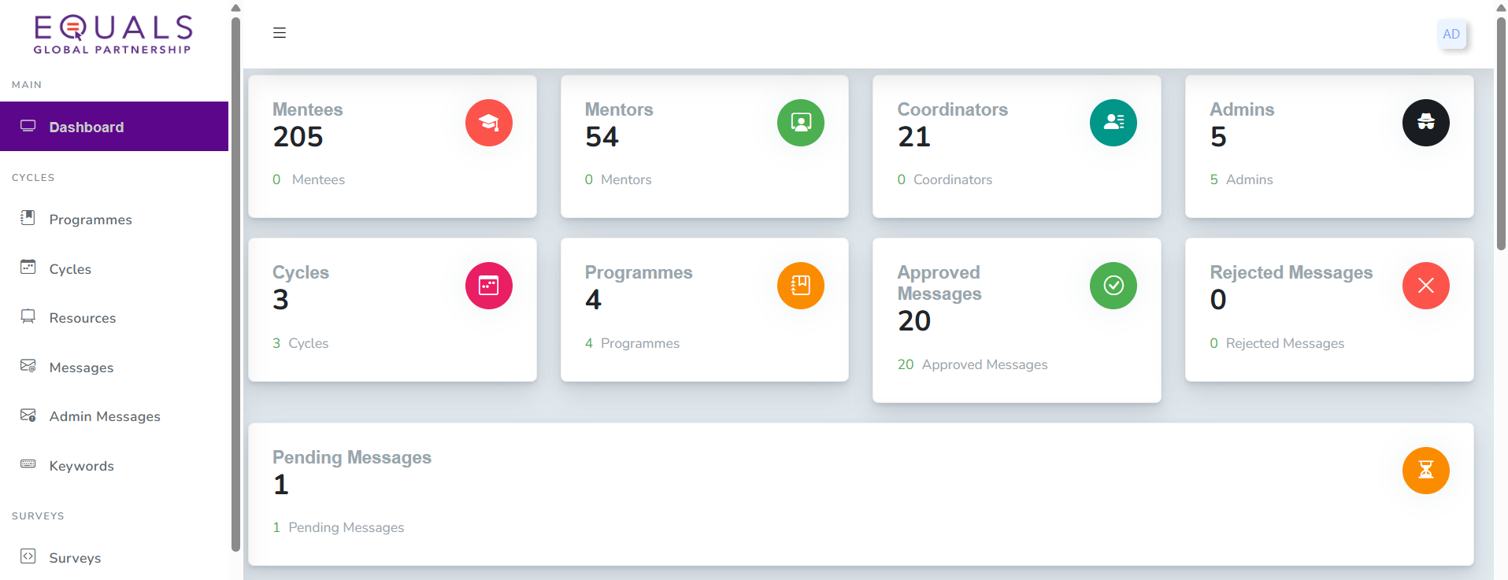

1. Participants’ (mentor, mentee) list

* I noticed that the mentor and mentee list on the dashboard display duplicate entries for individuals who have participated in multiple cycles. For example, if a mentor has participated three times, they appear three times in the list.
* Could we list each mentor and mentee only once, with the option to click on their profile to view details of all the programs they have participated in? This would align with the initial request to allow viewing past cycles/programs associated with a participant's profile.
* Is it possible for an admin to enroll a registered participant into a new cycle without requiring them to go through the registration process again? I haven't had the chance to test this on the platform yet, so I wanted to confirm.
* Could we list the cycles with titles rather than the timelines for easy reference and clarity.

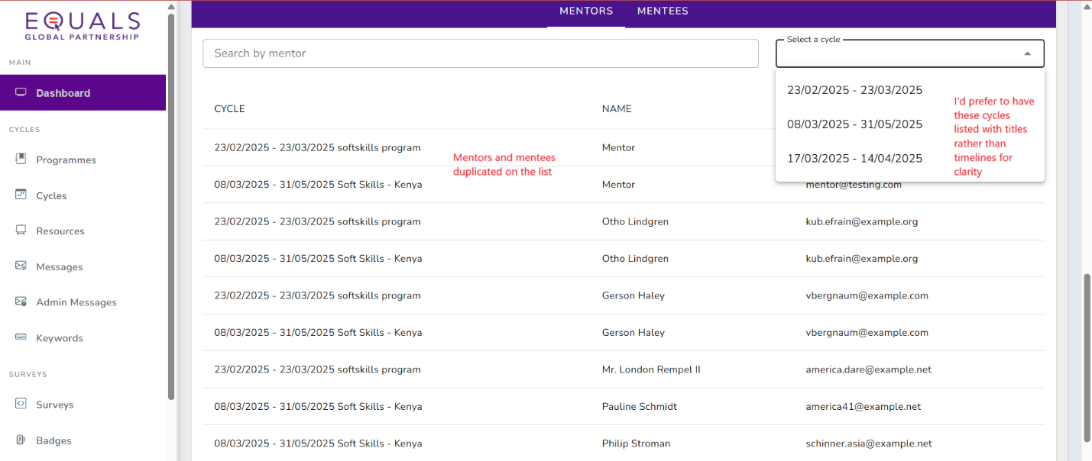

1. The "Export" button currently displays a tooltip that says "Export number of participants per programmes." However, when clicked, it generates a blank Excel file. Should this button also include an option to select a specific program before exporting the data?
   * Typo on the tooltip should be "Export number of participants per cycle”

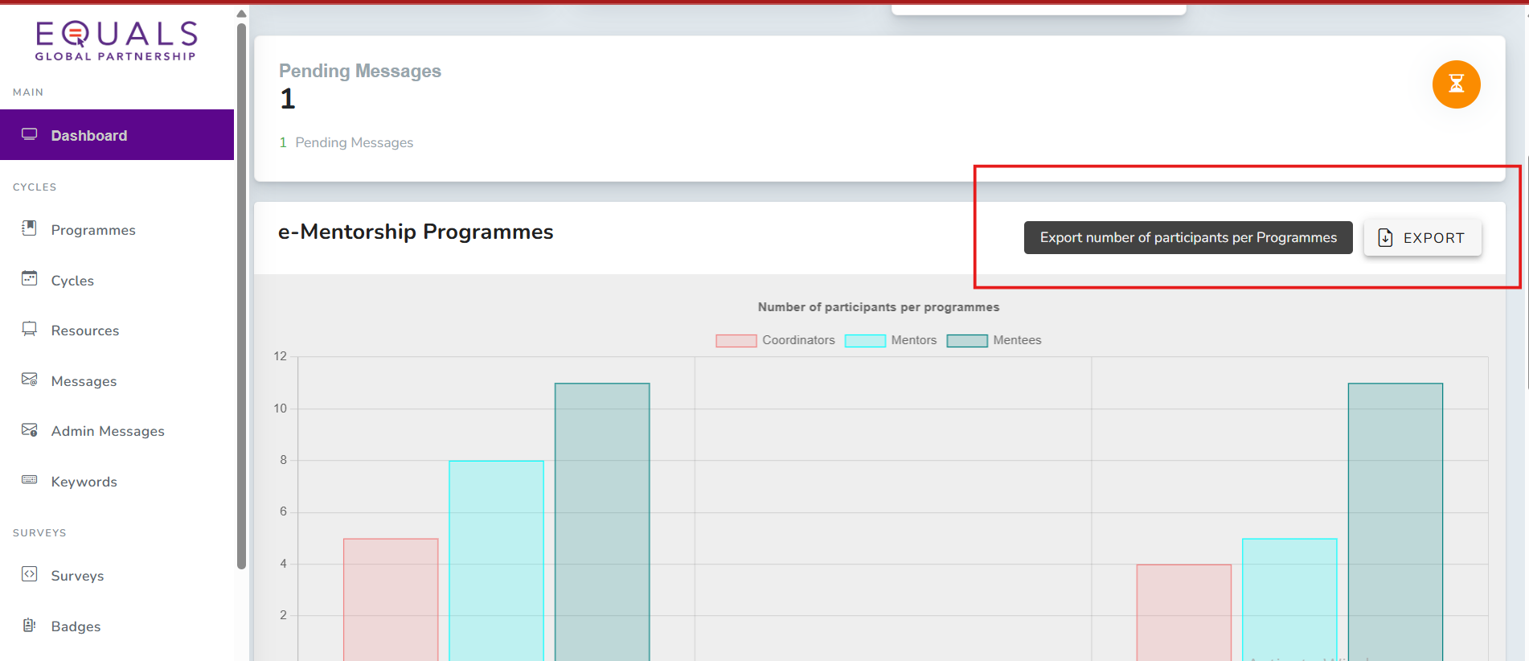

1. Creating cycle
   * Could we have an option for manually adding the cycle name for better identification and tracking of cycles. E.g. adding a tag like January 2025 for each cycle

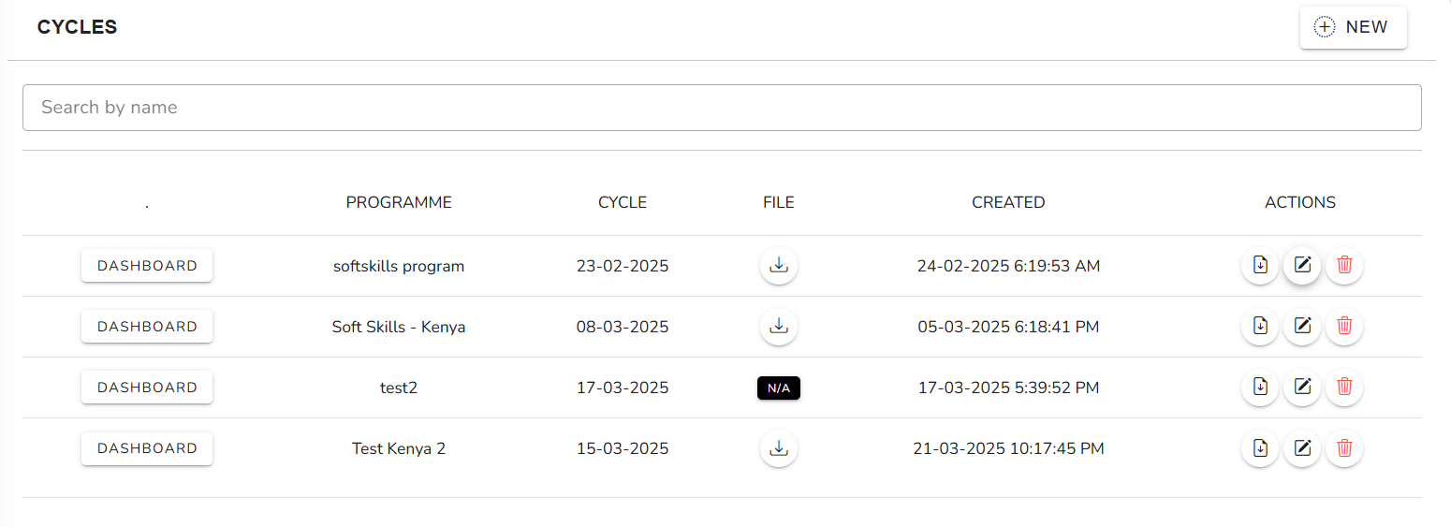

* Currently when uploading documents for the weekly topics I noticed that we can only upload one document for the mentors and one for the mentees. It would be helpful if the platform could allow the flexibility to upload multiple docs for each group ensuring we can provide a variety of resources for each group.
* Currently when reviewing the weekly topics in the program, I can see that the files for both mentor and mentee are listed but when I click on the file, it prompts me to upload a new file instead of reviewing the files that were uploaded. Since it possible to review these files in the cycles, it would be helpful to have the ability to review the uploaded files in the program view

